The BERA Asian Pacific American Association and English for Speakers of Other Languages

proudly present

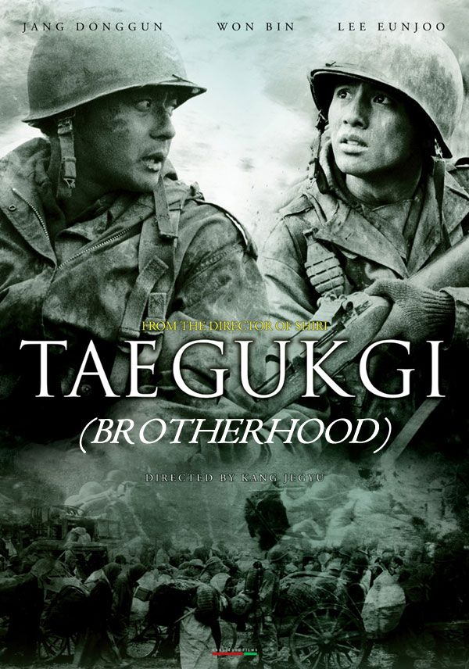
"Epic in scope and violent in a way that every war film has to be since Saving Private Ryan, Taegukgi is a big-time movie that never loses sight of its human story."
-- G. Allen Johnson, SAN FRANCISCO CHRONICLE

"Writer/director Kang Je-gyu dedicates himself to the human side of a grand tale, to people who've been uprooted by history."
-- Robert K. Elder, CHICAGO TRIBUNE
"The battle scenes are amazing in their scope and vehemence. But in the breaks between fighting, the movie reminds us that the costs of war can exceed the loss of life and limb."
-- Jeff Strickler, MINNEAPOLIS STAR TRIBUNE
"Brutal yet meaningful, agonizing yet touching, The Brotherhood of War is a harrowing but rewarding experience."
-- Bruce Westbrook, HOUSTON CHRONICLE
"A complex film about the minefield of loyalty and betrayal."
-- Michael O'Sullivan, WASHINGTON POST
"Successfully combines audience-friendly sentimentality with absolutely grueling combat footage and an unexpected but unmistakable hostility toward the entire notion of war."
-- Kenneth Turan, LOS ANGELES TIMES

MPAA Rating: R (strong graphic sequences of war violence)
Running Time: 2 hours, 20 minutes

Brotherhood tells the dramatic tale of two brothers forced to fight in the Korean War, and how that conflict lays siege to their family and friends.

Join us as we watch this outstanding movie from Korean director Kang Je-gyu!

Date: Friday, June 23rd
Time: 7:00PM
Place: Biology Building 463, Seminar Room (1-57)

