My name is Jeena Sharma, 23 years old.I live in Kathmandu and I am a graduate student of Kathmandu University.

I'm exposing Nitesh Pariyar now. He's a liar!
He deceived my feelings and body. After sleeping and having sex with me, he promised to let me join NCELL company and become his private secretary. He also said he would marry me.
He is a complete liar!!!
After he slept with me and had sex, he ignored me, didn't answer my phone or any message, and pretended not to know me!
When he was dating me, he lied to me that his name was sum, but after my follow-up investigation, I found his true identity!
After my covert investigation, I would also expose Nitesh Pariyar corruption, accepting bribes from many people, and sleeping with other women.
Nitesh Pariyar !!! I have photos and videos of you sleeping with other women. If you don't compensate me, I will send the photos to all your colleagues, friends and family!
Nitesh Pariyar !!! I will make all your evidence of corruption and cheating photos into documents and ruin your reputation!

Other women!!
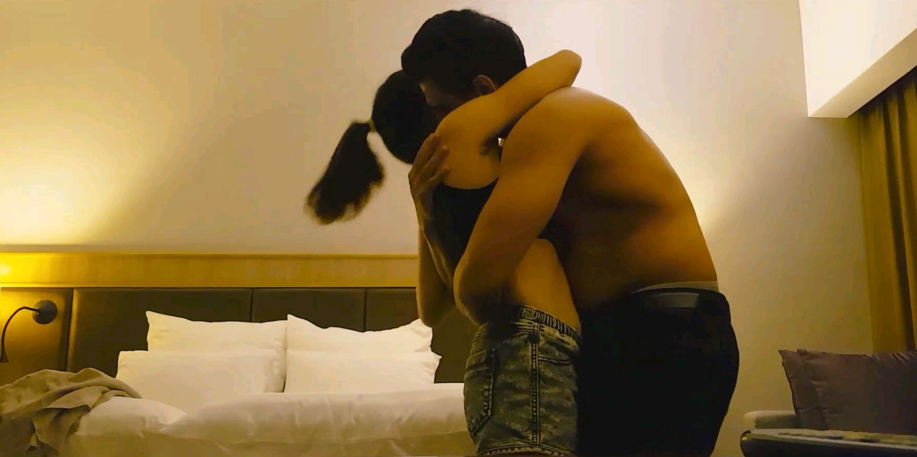

Other women!!


